Atten User Manual

This app is for automated fibre loss calculation.

App main page:

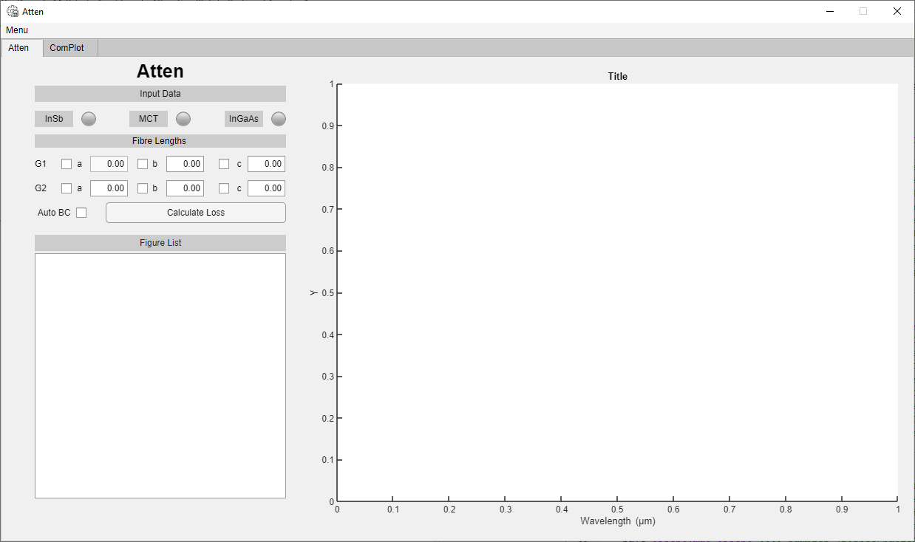

Step 1: Load data into Atten

Option 1: Via Excel.

The app currently only works with 3 fibre sections for each group (i.e. 1a, 1b and 1c, and 2a, 2b and 2c). So when uploading your data via excel, ensure it is arranged like the image below for each detector.

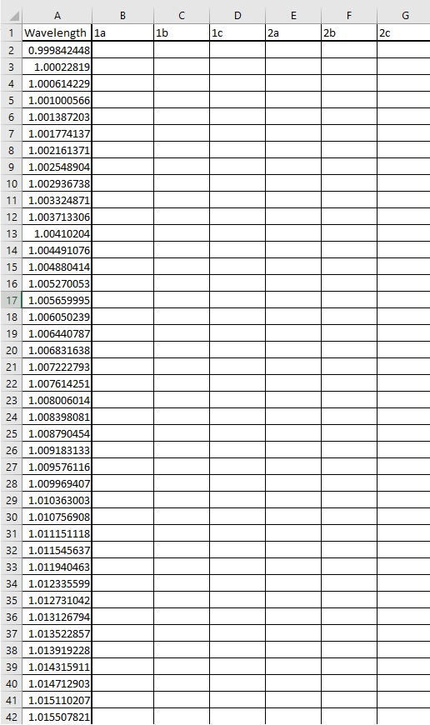

Option 2: Via Opus.

1: Sort all the data you want uploaded into a folder. Ensure that each detector is labelled correctly, and you have each section also labelled. See image below. The rest of the file name is not significant.

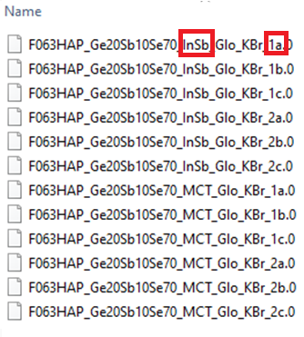

2: Select “Load>Input Data>OPUS”, then press “Load” on the new window that appeared. Now select the folder containing the opus files and load into the app. The image below is an example of what appears when you have loaded the data into the app.

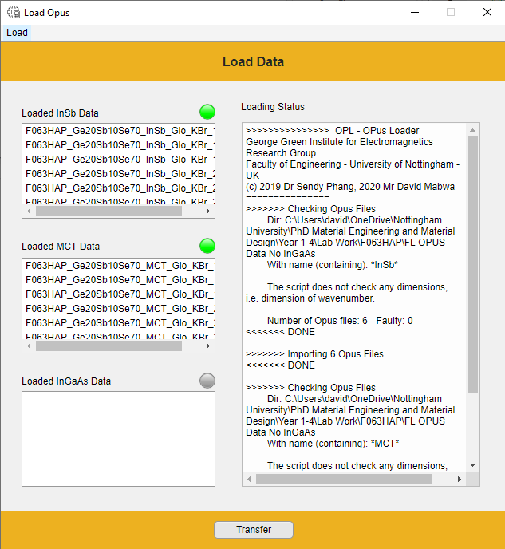

3: Now highlight which files you would like to transfer into the main app.

* Note that the app currently only works with 3 fibre sections from each group (i.e. 1a, 1b, and 1c). Therefore, only load 6 files from each detector.
* Note: You can only load data from 2 detectors.
* Note: When selecting the data, select from top to bottom.

See example below.

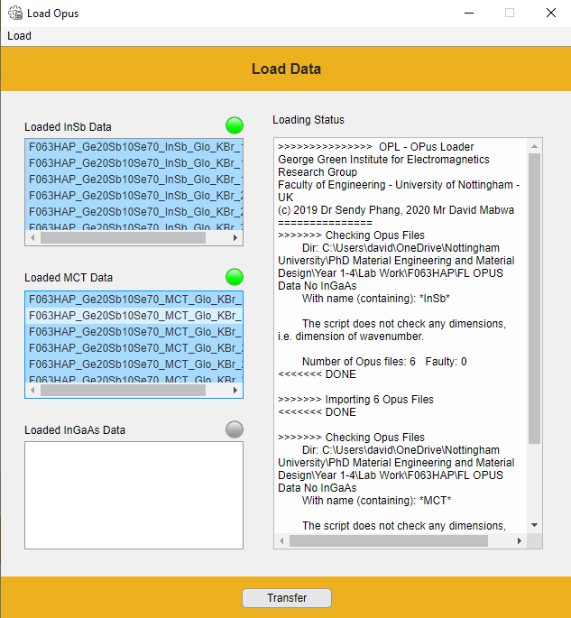

Step 2: Once the data is selected, press transfer. This data will then be transferred to the main window of the app.

Now enter the fibre cut out lengths for each section in the spaces provided and select whether you’d like the software to select the best cleave for you or whether you’d like to select it manually. If the latter, then tick a box in G1 and G2. If the former then click “Auto BC”. See example below.

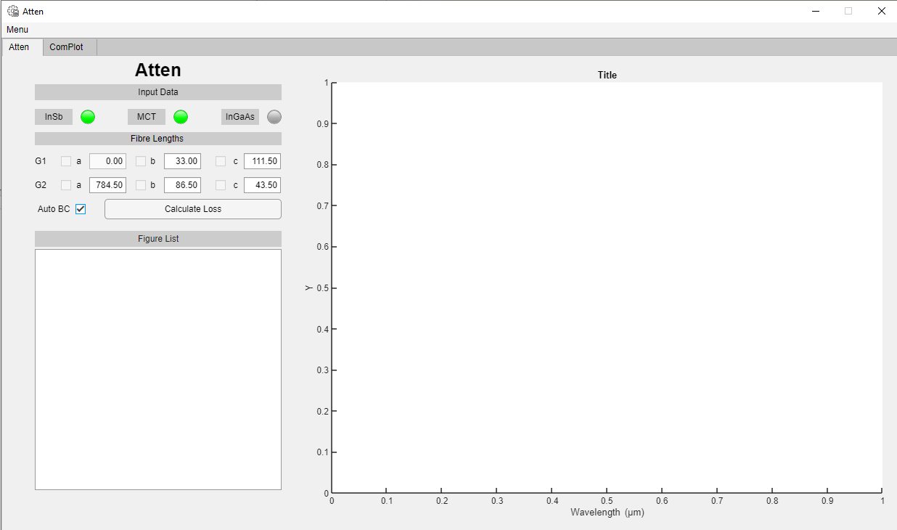

Step 3: During the calculation, you will be requested to select a region of the plot, to match MCT with InSb. Use the cross hairs that appear in the new window to do this. Click on the region you want to match the plots and press enter. You will then be presented with a window to confirm your choice. Click okay to continue or enter a new spectral region then press okay. See example images below.

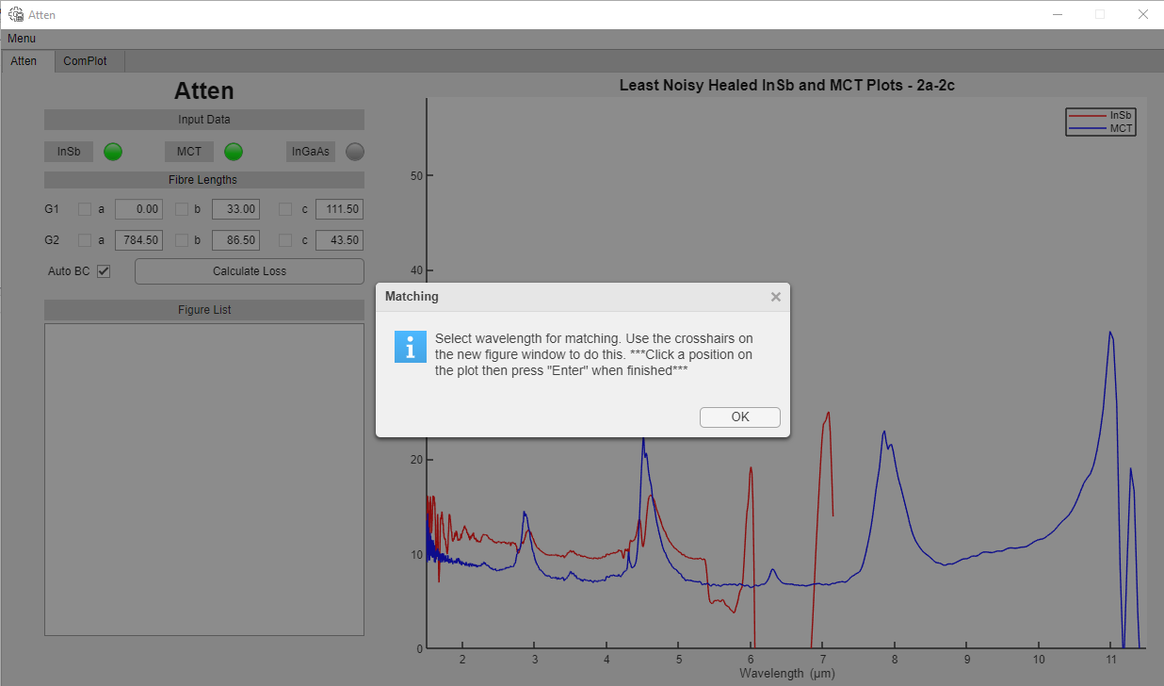

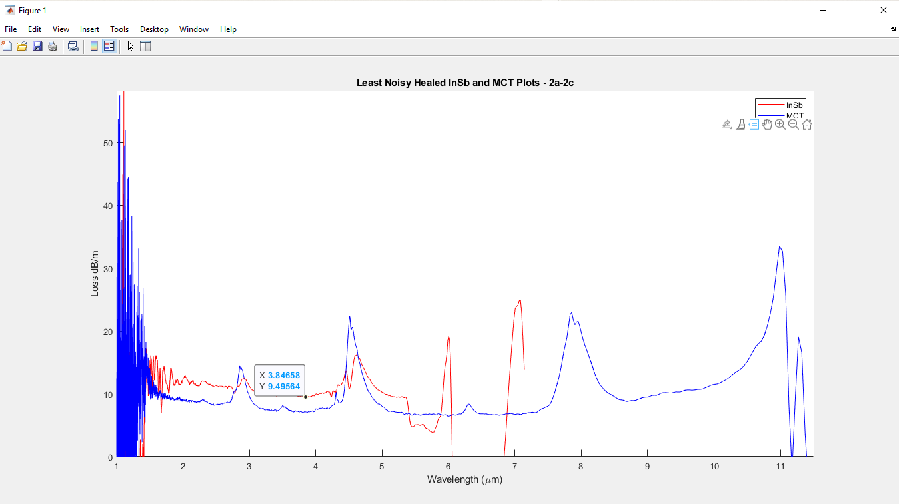

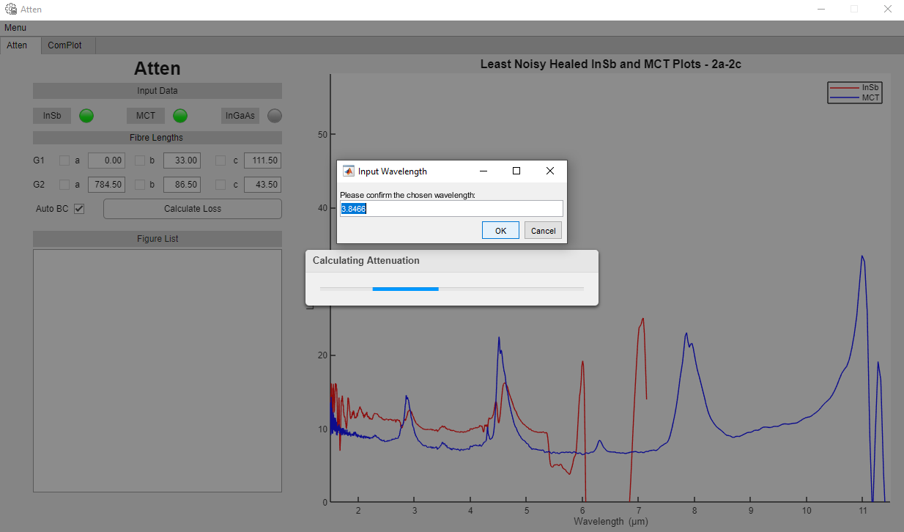

Step 4: You will then be presented with another request to select regions of the plot where you’d like to cleave the original peaks of the original attenuation plot with the healed peaks of the healed attenuation plot. Use the cross hairs that appear on the new window to do this. **See example image below.**

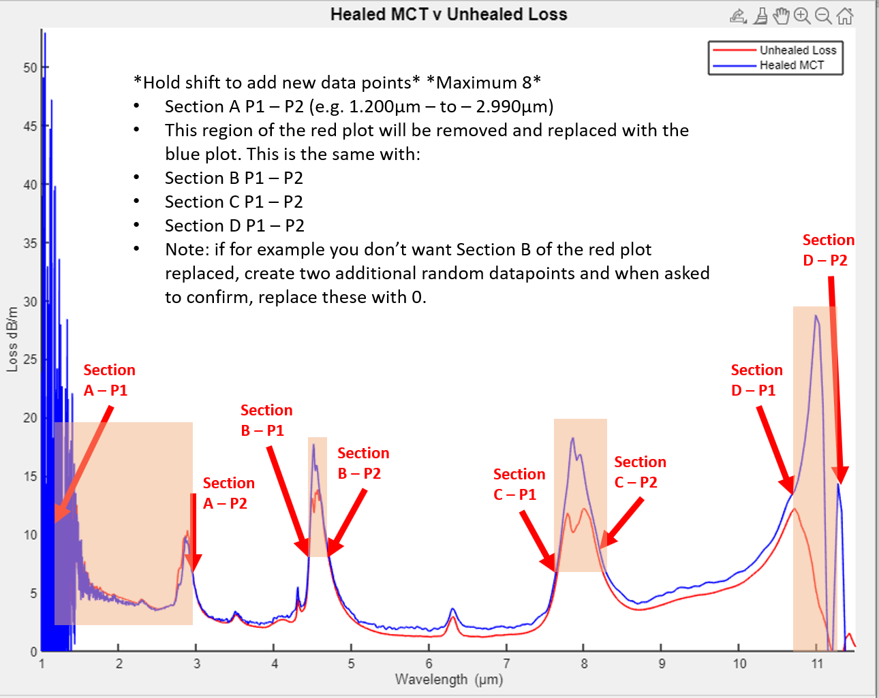

You will then be presented with a window to confirm your choices. Click okay to continue or enter a new spectral region then press okay. If you don’t want a section to be replaced, click two random points in that region and when presented with the window to confirm your choice, replace that with 0. See example image below.

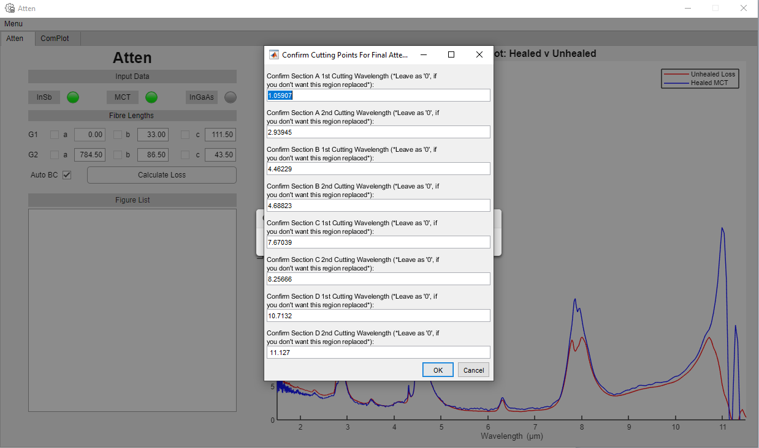

Step 5: Finally enter the fibre code and composition of your fibre and press ok.

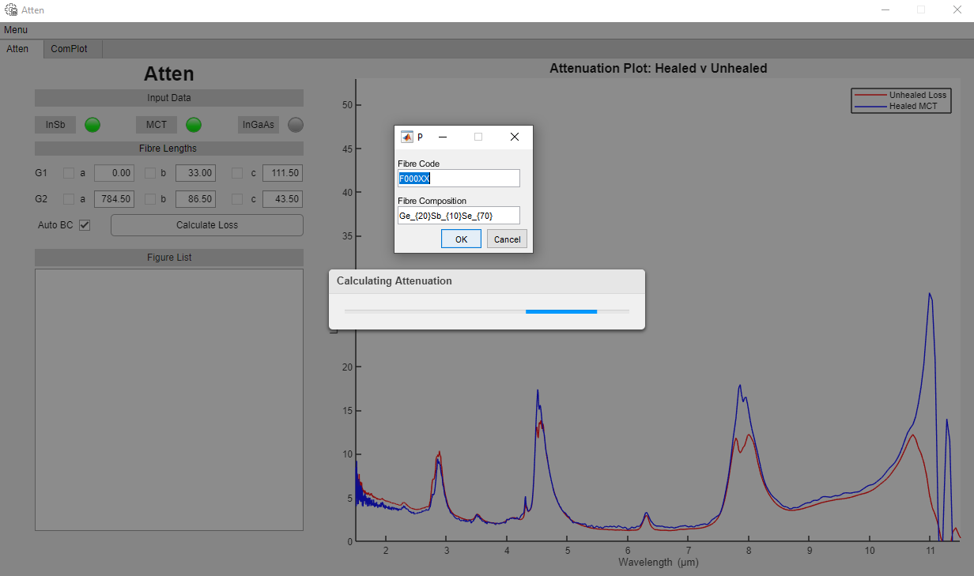

The completed app alongside all figures

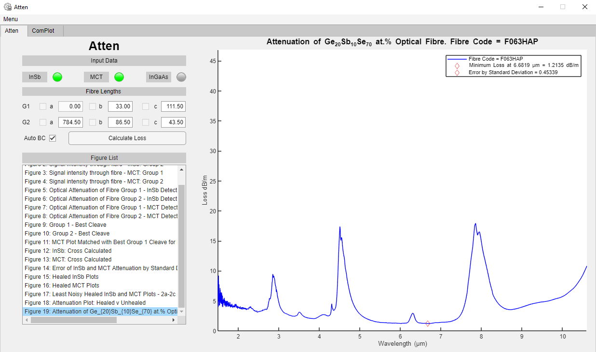

Complot user manual

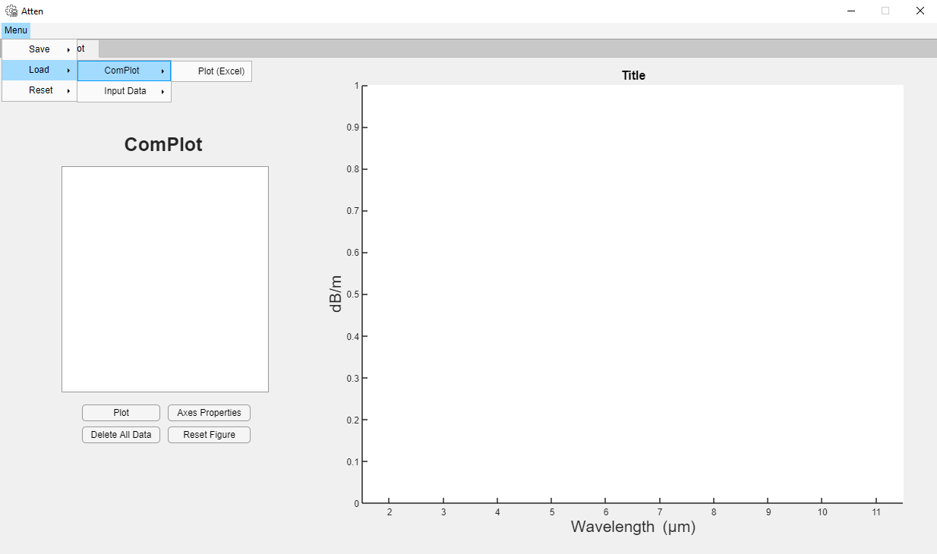

Use complot to compare multiple fibre loss measurements generated by Atten. The data is arranged so that X Data is the first column and Y Data is the second column. If you wish to compare other plots, then ensure that the data is arranged as such. Otherwise Complot will only plot the first two columns.

* Note: Load each plot you want to compare and press the plot button. This will plot every loaded plot in the list.
* Change axes properties by pressing “Axes properties”.
* To load new unrelated data, press “Delete all data”.
* To reset the figure, press “Reset Figure”.
* If you want to compare new data, you can either press “Delete all data” and “Reset Figure” or just click Menu>Reset>Complot.